Challenge Group Post Ideas
Jenelle Summers
October 2015

2 Days Before
Hey Fit Friends!!!
I'm just getting people into the group today.
I’m SO excited to see who digs deep and gets RESULTS! I will be your support & accountability!
1) Take measurements & weight .. you don't have to share this, but please write it down somewhere if you want to be eligible for a prize at the end. The winner will be the person with the best transformation (%of body weight and inches) and support and participation to the group!
2) Take pictures from the front, side and back in a bathing suit or bra top & shorts (you don't need to show pics to us, but should you choose to, for accountability purposes, the group is "secret" and can't be seen by others)
3) Remove ALL trigger foods from accessibility (hide or pitch!! Do it!!!)
4) Plan what days/times you will workout and STICK TO IT or find a way to fit it in even when it's not ideal or has to be shortened or modified!
5) If you're NOT doing the 21-Day Fix, go to FreeDieting.com - input your info into the Daily Calorie Needs Calculator to see what your ideal calorie range should be for fatloss (do NOT use the "extreme" number). This will be approx the number you want to eat daily regardless of what you burn in your workouts.. do not go too far under or over this calorie allotment. Too far under is BAD-slows metabolism. This is just to know you’re eating the right AMOUNT, but WHAT you eat definitely impacts results too!
6) Please think of a time where you'll regularly report back on this facebook group!
THANKS!!! Who’s in??? Please check once a DAY!!

1 Day Before
Hey Fit Friends!! Lets get some work done! This group is only 3 weeks! So let's get some results asap!
Please report back on this facebook group, the following info by tomorrow :
#1) Ideal Calorie range from the FreeDieting.com site (unless you're doing 21-Day Fix, you should just know your #'s but please say you're doing 21-day Fix if you are)
#2) Measurements & Weight (you can pm me that info or just keep it to yourself if you prefer)
#3) What your struggles for weightloss are or have been (you can list MANY), whatever you're willing to share, but the more I know, the more I can help and we can ALL help each other!
#4) What are your goal(s) for this challenge!
#5) What was your workout today?? Are you willing to track food intake for this 21 days? You don't HAVE TO, but I'd recommend it
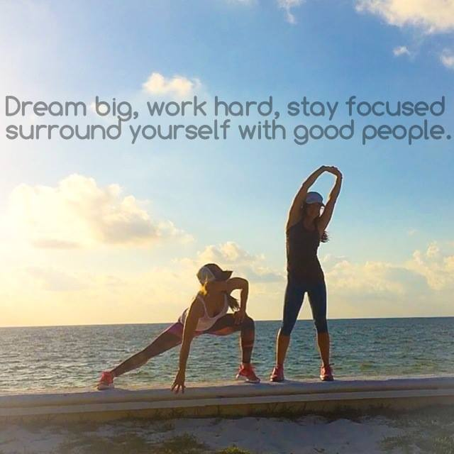

Day 1:
Hey my friends!! It's [DAY OF THE WEEK] night – day 1! When your day is over (and your kitchen is "closed") please report below on how you did with:

1) Your workout. What was it? How intense was it on a scale of 1-10, 10 being "It was so intense I wanted to throw up" (just kidding! but your 110% max intensity) and what was the duration of the workout?

2) Your nutrition. Did you hit your goal? What did you NOT eat that you normally eat/drink? Are you trying to stop eating by a certain time and did that? Are you trying to avoid pop/soda and did that? Are you estimating calories throughout the day or macro nutrients and hit your goal?

TIP of the DAY: You're going to have those days where you feel SO tired or stressed that you feel you're ENTITLED to eat something sweet or "bad"..when that feeling comes over you, distract yourself with something you like to do (maybe check this group for motivation!) and get yourself out of the environment so you can think more clearly and make a conscious decision. No one can help you more than YOU. Plan ahead with meals and snacks so you're not putting yourself in the position of feeling STARVED, or overly tired which causes more bad cravings.
At the same time, feeling deprived can backfire too. So buy or create some meals/snacks/desserts for you and the family that are a "transition" from what you & the family might normally splurge on, but are healthier and still taste good .. but not SO good that you want to have more than 1 serving.
Thanks for opening up with us and being COMMITTED to report in daily! We're in this together!

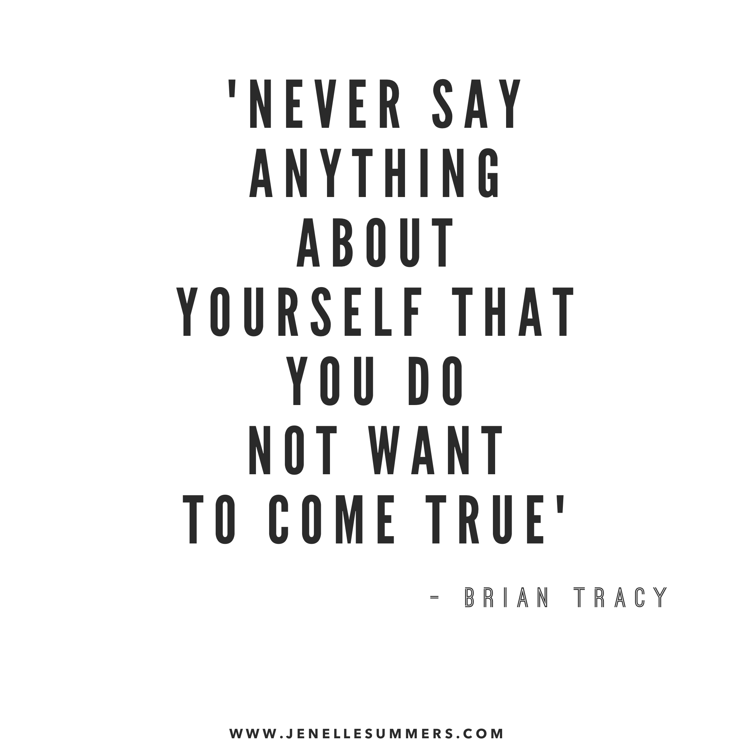

Day 2:
Hey Fit Fam! It's [DAY OF THE WEEK] night!
First of all…how'd you fair today? Please report below:

1) What was your workout? What was the intensity & duration?
2) Did you meet your caloric, or macro, or clean eating goals today??

TIP OF THE DAY: If you have aggressive goals for yourself and you know your downfall is unnecessary nighttime snacking/splurging, then stop buying those types of foods that tempt you or at least remove them from sight/access and also try to stop eating after a certain hour - a few hours before bed. Again, I'm not a nutritionist, but what's helped me over the years is to have some tea or decaf coffee and/or air popped popcorn (has antioxidants and is naturally low on calories, sugar, sodium, etc) when I feel the need to have something and I know it's not hunger at all; it's just that I WANT *something* to snack on or sip on. There are some options that come in 100-cal bag servings like SkinnyPop so that you're not overeating (if that's an issue for you). What do YOU all do that has helped??

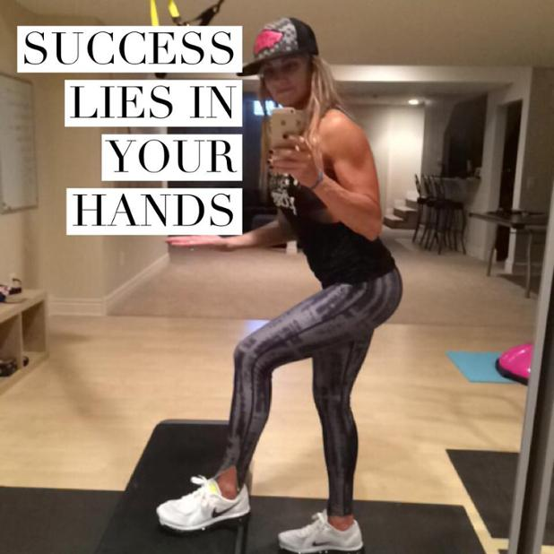

Day 3:
Hey everyone! It's [DAY OF THE WEEK]. How'd you do today with your workout and your nutrition?? Did you fit something in? Did you meet your nutrition goals?
When you check in, feel free to post a pic of a healthy meal you ate or a recipe you made!!!

TIP OF THE DAY: Build a Metabolism That Burns More Fat!

After years of talking to people about eating & exercise habits, what i see most often sabotaging results is INCONSISTENCY; usually with nutrition - and it's usually one extreme to the next! One day they're claiming a 300-calorie meal is too many calories for them (what!?!?) & they're analyzing EVERYTHING on the label. The next day they're eating an unknowingly high-calorie dinner (900 calories but they say "but it was the "healthy menu" choice) followed by a couple glasses of wine -probably AT LEAST 1200 calorie dinner.. not that uncommon when you're eating at a restaurant. If you've trained your body to survive on such a LOW calorie intake on most days, then your body will want to store most of that dinner as fat...because you've trained your body to effectively conserve, i.e. store more calories as fat, because so few calories are coming in on a regular basis.

So many of the menu items at restaurants SEEM healthy, and some DO have a lot of nutritional value in them, but the portion sizes are usually way off and the recipes also have LOTS of hidden ingredients-butter/sugars/carmelized nuts/sauces - that you don't even realize are there and are surprisingly SUPER high in fat, calories, sodium, and sugar.

I'm NOT saying eat perfectly, skip eating out & having yourself a drink once in awhile ... i'm saying, you might need to build up a healthier metabolism and be more AWARE and MUCH MORE consistent. The way to build a healthier metabolism is to gain more muscle and EAT within a RANGE of calories you SHOULD be eating daily... given your size, age, and your activity level. You don't have to count every calorie or macro for the rest of your life.. you'll be able to "eyeball" it eventually

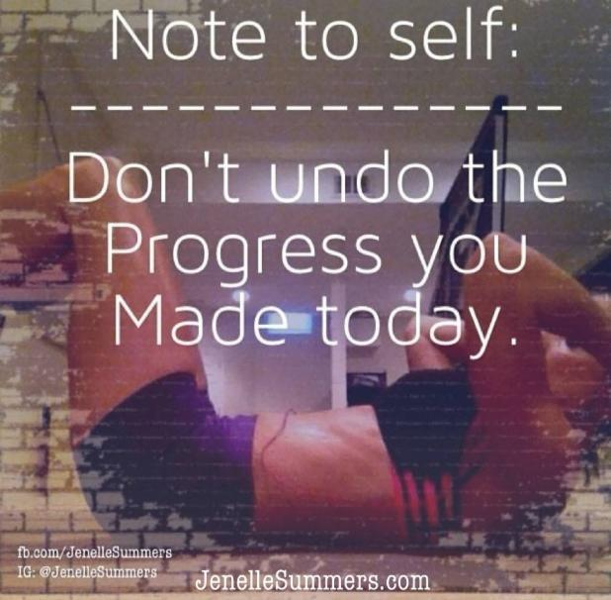

Day 4:
Hey Fit Friends..it's [DAY OF THE WEEK]!
How was your nutrition & workout today? What did you eat & what did you NOT eat?

TIP OF THE DAY: You're success with this group will depend on how badly YOU want results. Here are some tips:

1. Drink tons of water. How much? Divide your weight in half & drink that much in ounces.
2. Track your macros (we've talked about this). You may be eating healthy but too many carbs, too many "good" fats, too much sugar due to too much fruit, etc. If you don't do well with tracking, try to eat something high in lean protein at each meal & lots of veggies!! This is why I do salads & shakeology ..two meals I know for sure will be high protein & veggies.
3. Don't let the scale be your measure of success!! You will be gaining water weight, muscle weight & losing fat.. Who knows what the weight gain is or what the loss is.. Rely more on trusting the process, how you feel & pictures
4. Lift weights! Build a better fat burning body!
5. Don't skip meals or be too restrictive.. It can cause your metabolism to slow & muscle loss. It can also lead to binges.
6. Add HIIT workouts to your workout regime.
7. Get enough sleep. When you're tired, your cravings tend to be worse.
8. Don't go more than 2 days without a workout. Mentally getting back on track is SO much harder with each padding day. Even if it's just a 4 minute tabata & a 5 minute stretch.. Do it. Mentally you will feel on track & that's huge!
9. Stay engaged with groups like this & people like us! All of you in here have a coach. Update him/her or tag them when you report in
10. Don't give up! If you are feeling off, get back on ASAP. Don't dwell or beat yourself up. Learn from your mistakes, tweak what you can to solve your own issues/habits & move fwd

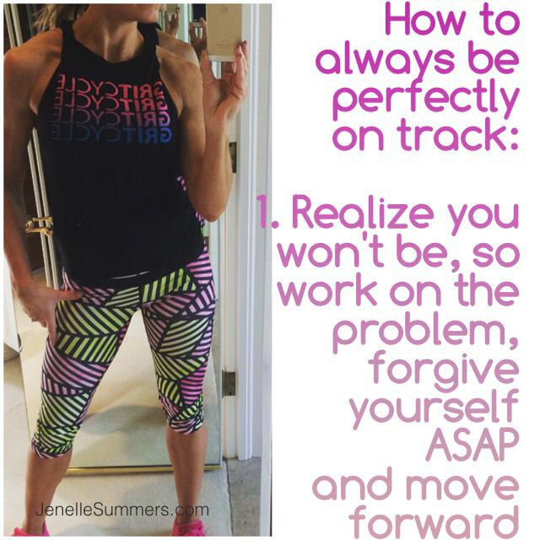

Day 5:
Good evening! It's [DAY OF THE WEEK]!
Check in below with how your nutrition was for today as well as your workout intensity and duration!

TIP OF THE DAY: To gain strength and/or flexibility or speed or whatever you want to improve on.. you HAVE to push past that point where you normally tell yourself you're DONE, or past the weight you normally lift, or past that point you normally stretch to. It's NOT comfortable. But doing so tells your body is has to adapt to new demands and it responds by improving. You know this, I know you do, but are you remembering to actually PUSH yourself during your workouts. Are you going BEYOND that rep you *think* should be your last?? When you think it’s your last rep, try to do 4 more with good form even if everyone on the video is done. The videos are created for a mass audience, you may be able to do MORE.. so do it! You make your strength gains when it becomes REALLY uncomfortable. To be honest, I'm usually swearing under my breath! LOL So, push yourself to make it COUNT. Just be sure you keep your form :)

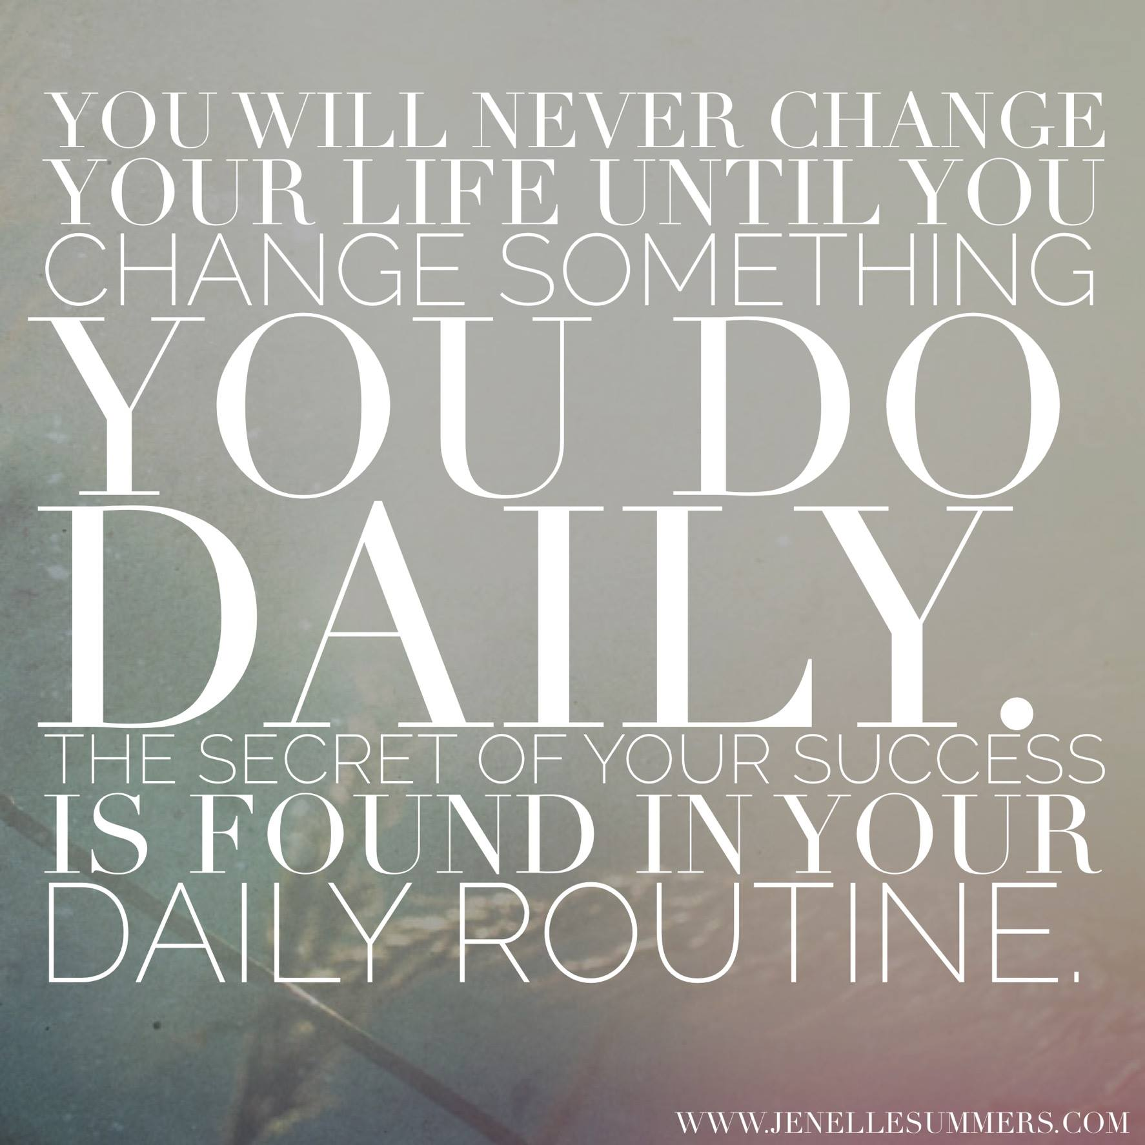

Day 6:
How was your [DAY OF THE WEEK] Nutrition-wise & workout-wise??

TIP OF THE DAY: Which one are you struggling with??
You have to keep tweaking what you're doing until you find that right balance that works for you, given YOUR lifestyle, YOUR weaknesses, YOUR goals ...and then you have to be PATIENT.
Once you are working on all of the above CONSISTENTLY for 8-12 weeks (with a #‎NOEXCUSES‬‬‬‬‬‬‬‬ attitude), that's when long-lasting results start setting in & long-lasting habits start forming!
To accomplish what you NEVER have before, you have to GIVE UP and TAKE ON some things you NEVER have before. #‎RealityCheck‬‬‬‬‬‬‬‬✔

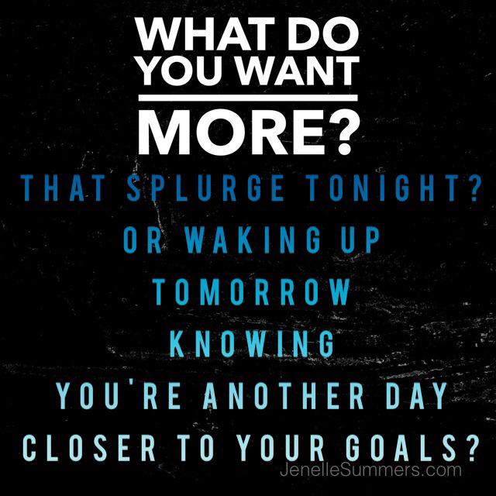

Day 7:
Good evening Fit fam!! It's [DAY OF THE WEEK]!
How did it go? Please report below on where you ended up with your nutrition and what workout you did. No matter what happened, still report in.. it's what will keep you accountable. If you cringe to write that you didn't do well, writing it and sharing with us will cause you to be less likely to REPEAT the activities.
No one and especially not me, is expecting perfection... just progress and optimism!!

TIP OF THE DAY: I thought I'd touch on some things that keep me motivated. First of all, wanting to be a good example for others keeps me motivated and not wanting to give up. Secondly, MUSIC motivates me.. so even if you're using a DVD when working out, once you know the routine, you can play your own music on your headphones and really get into your ZONE.. some like relaxing music, others like upbeat. I love FitRadio on my iPhone! Third, buy a fitness magazine (I like Oxygen!) or follow some inspirational people's posts (Follow YOUR coach first and foremost and go to them when you want to buy product or join another challenge group, ..but for motivation you can also follow Lizzy on Facebook or her blog, you can follow @JenelleSummers on Facebook or Instagram, also on Instagram @TwoBadBodies, also @Snuppa32, @Yoga_Girl, @FitMenCook .. just to name a few! They have great tips, recipes!)

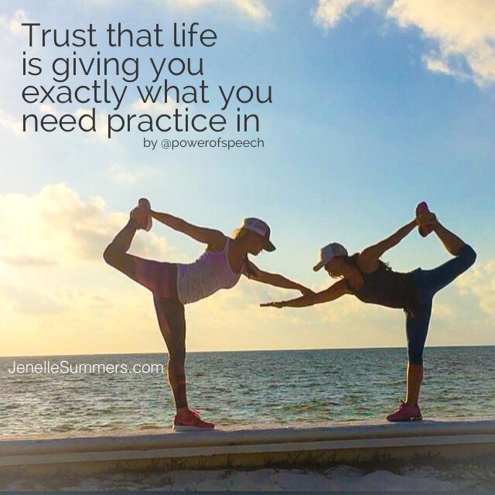

Day 8:
Hey team!! It's [DAY OF THE WEEK]! How did it go today ?
Even if you fall off track, PLEASE report below.. we won't judge, but reporting in will help you! Please report below on your workout (intensity & duration) and your nutrition, or what you plan to change this week to be better than LAST week!
Just some food for thought tonight, but I think you probably all would agree…

MOTIVATION FOR THE DAY: The whole point of being *truly* fit from the inside out is to evolve into the complete person you were born to be.
The biggest benefit isn't about reaching a certain size, a # on the scale, or ripped abs; it's reaching a healthy lifestyle and mindset that empowers you, makes you a better wife, mom, friend, employee/business owner, allows you to push forward to take care of yourself the best you can, at every stage of your life..thru injury, adversity, illnesses & unexpected set-backs.
All you can do is your best each day, keep the positive self-talk flowing, and THAT is true fitness from the inside out. So rock on team & let's finish this STRONG & in CONTROL!

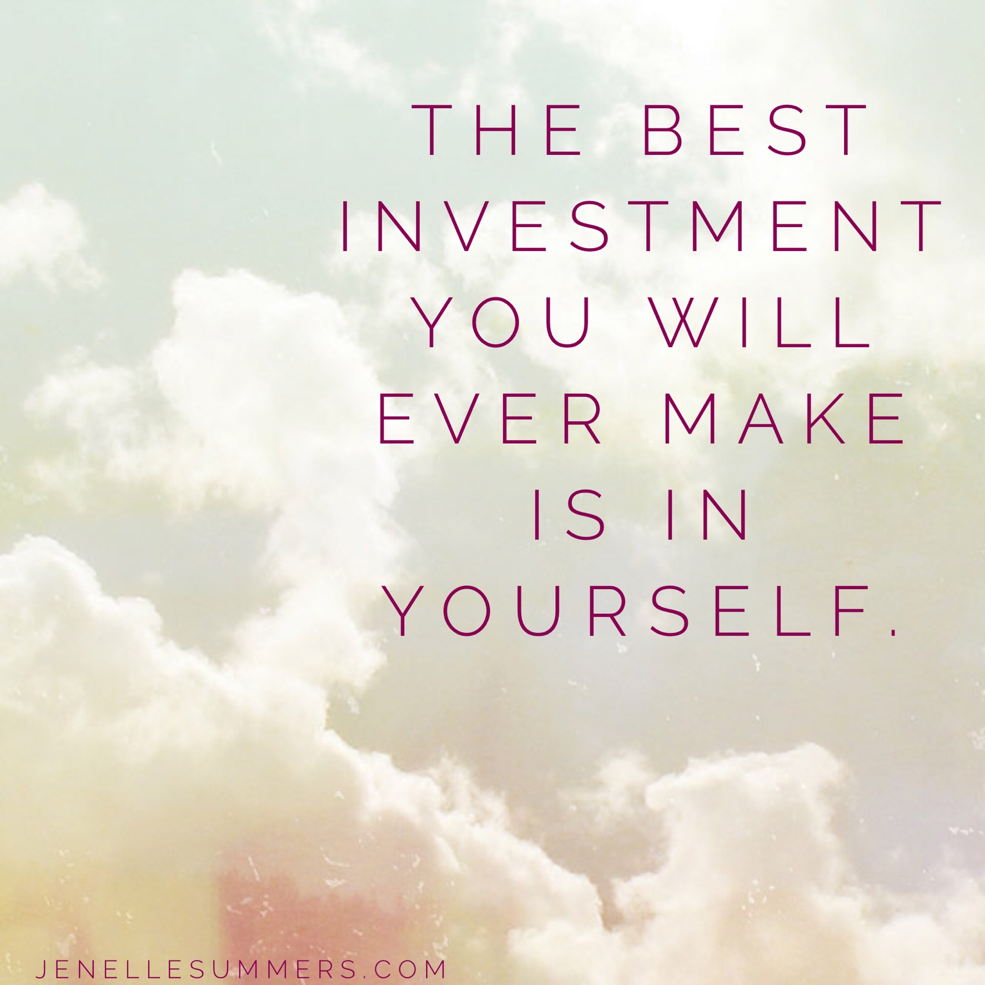
Day 9:
Hey All! Happy [DAY OF THE WEEK]!!
Are you still on track?? How'd you do OVERALL today??

TIP OF THE DAY: When you feel a craving for something "bad" coming on, distract yourself! Usually those cravings don't last long. Get yourself out of the kitchen (or wherever), or better yet, step outside.. get some fresh air.. if the craving is due to emotions/stress or boredom, turn to something you LOVE to do.. maybe it's reading a book or magazine, maybe it's browsing for new workout wear online, maybe it's checking your favorite fitness account on facebook or Instagram.. but either way, get yourself out of the environment and the mood that's triggering you. It's not that super fit people don't have these cravings and "slip ups", it's just that they've learned how to DEAL with them and learning to do so will help you get results for YEARS to come!

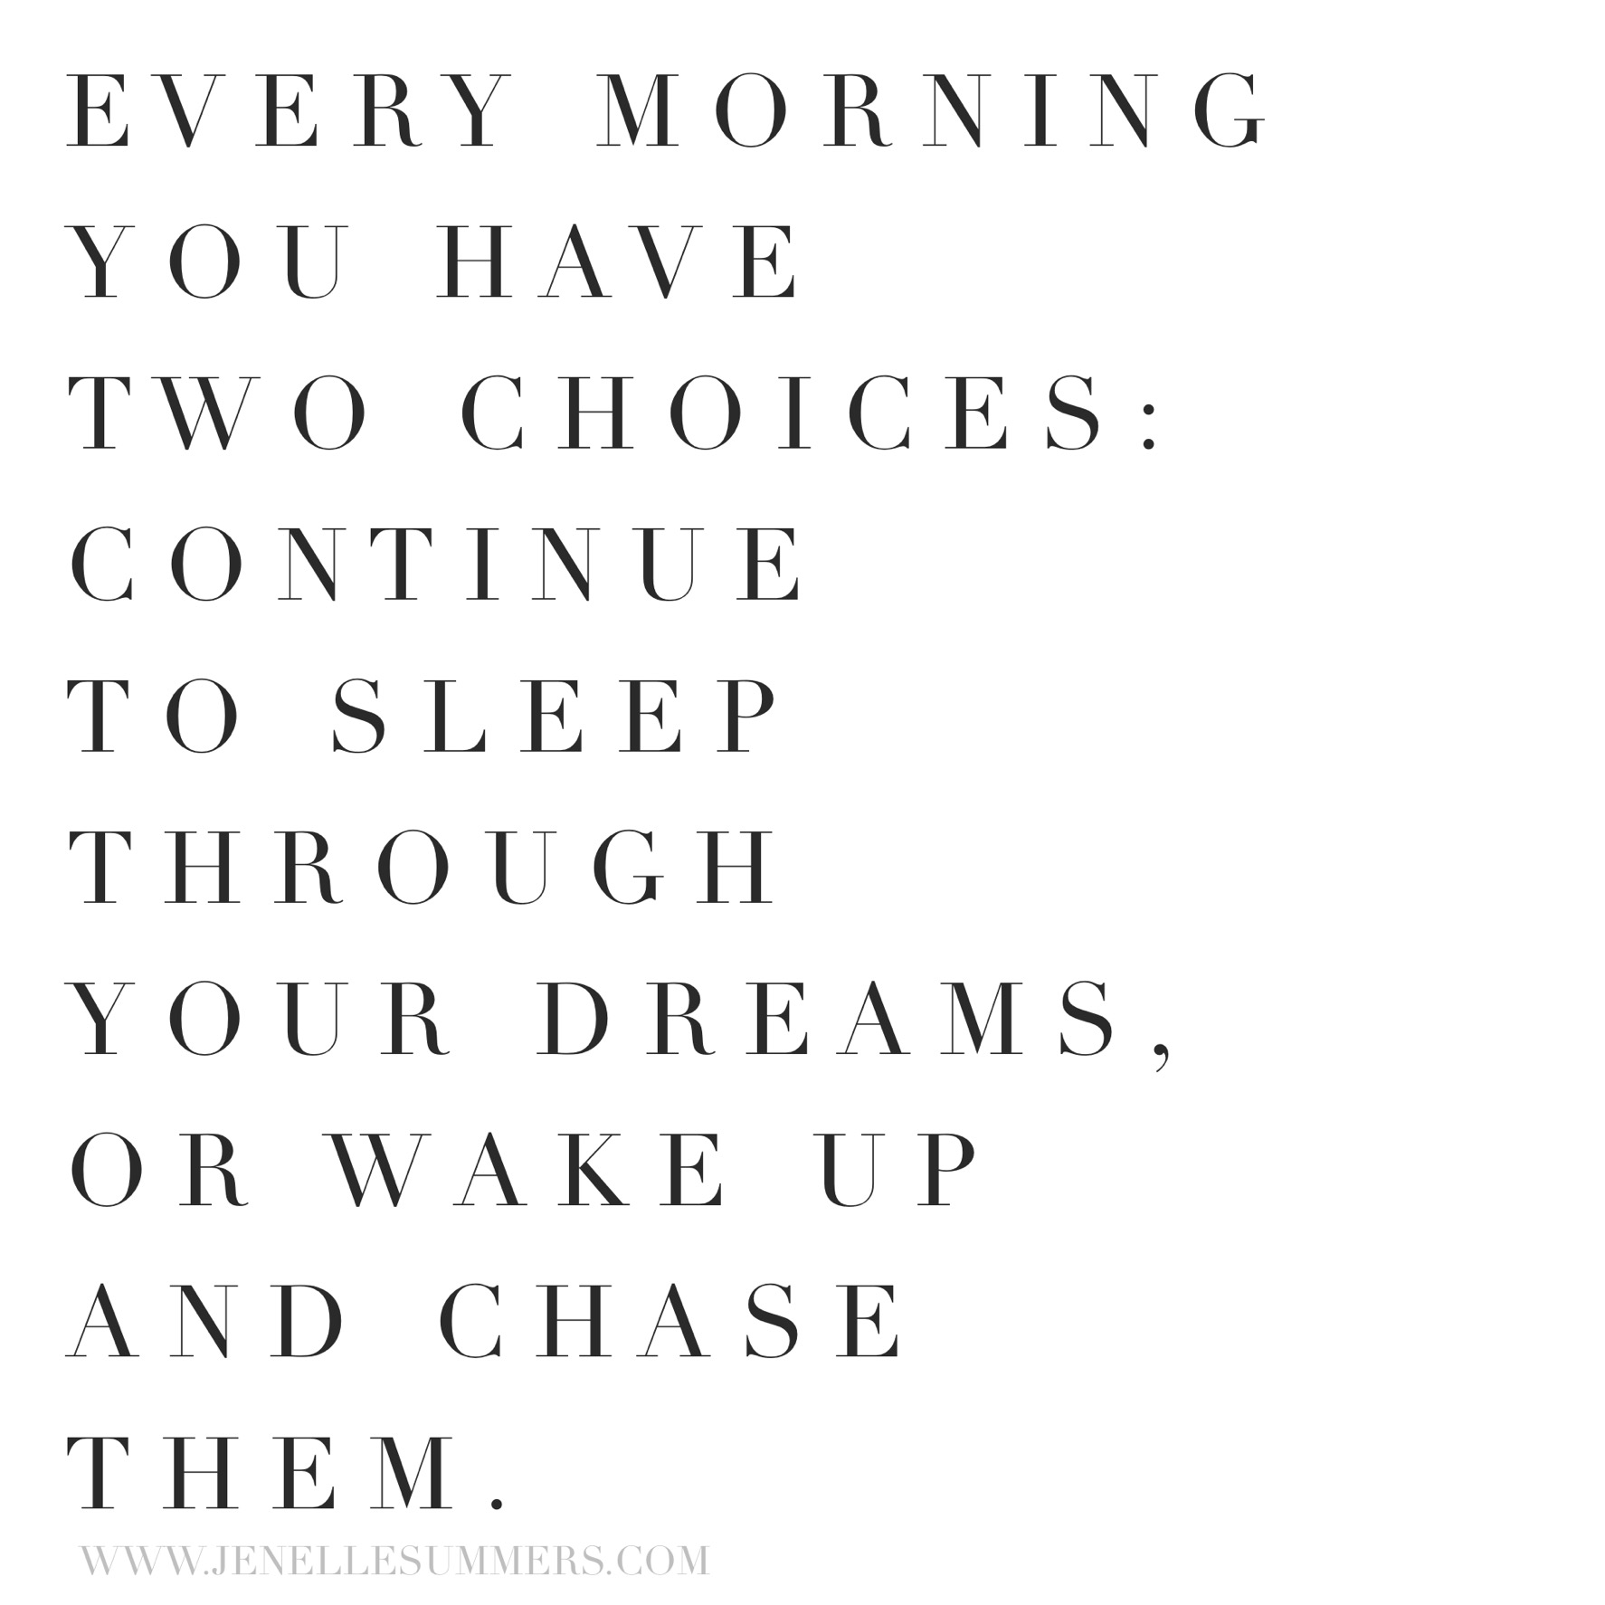

Day 10:
Happy [DAY OF THE WEEK] Check in below with your workout and nutrition for the day!

TIP OF THE DAY: Eating healthy/clean doesn't ALWAYS mean you'll lose fat - its entirely possible that you're having too many calories caused by too much of one of the 3 macro's - carbs, fats, & proteins, & therefore the excess calories, even if they are healthy calories, get stored as fat.
But that said, a lot of people DO see some great fatloss results just by eating cleaner b/c they naturally end up being more in range with the # of calories and macro nutrients they should be getting. So clean up your eating is step #1… for the health benefits if nothing else!
If you're eating/drinking junk regularly, there's almost a guarantee you'll have excess calories and "empty calories" that get stored as fat.
Then there are the foods PRETENDING to be healthy like fat-free foods that actually have such HIGH sugar - all of which is sure to be stored as fat. Have you checked sugar grams lately? Eating junk of course leads to a whole SLEW of health issues too. I'm not talking about the occasional splurge or certain foods in moderation
On the other hand, if you're consistently skipping meals, being too restrictive or yo-yo dieting, you'll slow down your metabolism & easily gain weight or not be able to lose, or will have a hard time achieving a fit body b/c you're not eating enough healthy foods to have energy for workouts or for muscles to build. OR if you are losing weight in that scenario, it's most likely MUSCLE & water weight you're losing.. & therefore you're not losing fat. With loss of muscle, again the metabolism is slower.. making it difficult to keep the weight off.
Lastly, GAINING weight doesn't necessarily mean you gained ANY fat. You may have gained water weight or muscle. Focus on progress pics and the way clothes fit and the way you feel. If you don't have a lot of fat to lose in the first place, often you will weigh MORE as you get fitter and stronger! Plz share what's helped YOU!

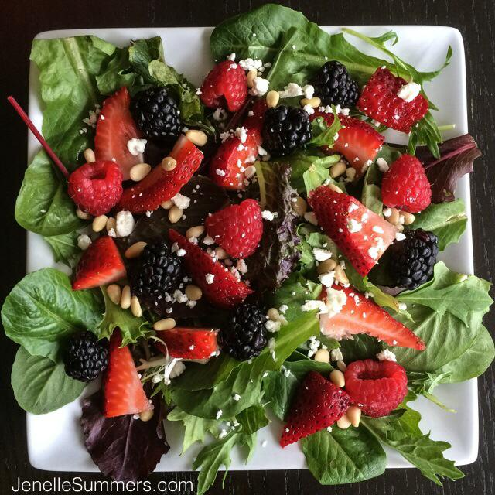
Day 11:
Happy [DAY OF THE WEEK]!! How'd you do with your nutrition and your workout?

TIP/THOUGHT OF THE DAY: Isn't it weird how you can feel SO on track one day, and the very next day, or even LATER that same day, feel SO off track and like you gained weight!?!?

I'm here to tell you .. you're not alone in that feeling and you probably did NOT gain a pound of fat in one day. When the scale says you gained a pound, please don't let your mind veer to the negative thoughts of defeat… chances are you're bloated or retaining water. Don't get me wrong, it COULD BE that some bad decisions in previous days or weeks are gradually catching up to you but when it's the next day or later that day, and especially when you have been doing well with nutrition and workouts, it's usually NOT that you've gained fat.. it's sometimes hormonal, or inflammation from a food you're sensitive to, or water retention, which can happen for a variety of reasons, or due to a high sodium food you ate! To gain a pound of fat, you would have to eat 3500 calories in EXCESS of what you burn.. and you're burning calories all day long even if you didn't workout. Chances are you did NOT do eat 3500 *excess* calories in one day.
So ..relax, be grateful for the health you have, and move forward. Deal??

Day 12:
Hey Guys!! Happy [DAY OF THE WEEK]!! Just wanted to say I'm cheering you on! If you feel you're about to "slip up" or go off track, ask yourself if it's REALLY worth it. You all deserve to feel that AMAZING sense of self-confidence and self-respect that comes with overcoming bad habits and negative emotions.
Stop permitting yourself to turn to food (or drinks) after a stressful day or situation. It's NORMAL, but it's not healthy. Save those splurges for special occasions! If you don't, it's a never-ending cycle and you have to TRAIN your brain! It's never too late to figure out how to get in the BEST shape of your life and learn how to manage stress, emotions, busy days, etc so that you can CONTINUE to improve year after year (versus gaining it back). Do some problem solving on your weaknesses and issues. Ask ME .. i'm here for you! I'll check this group at least once per day!

Day 13:
Hey Friends! Happy [DAY OF THE WEEK]
I just wanted to share this with you - Please stay on track today. Not for ME, for YOU.
The results you see TODAY might be 80% due to the nutrition habits you've had in the past months and year. But your results TOMORROW are 100% due to the mindset you adopt TODAY & KEEP.

Don't be too stubborn to make the changes you know you need to make. Stop telling yourself, well I can't do ____, because i'm not ____. And I'll never be ___ because i'm not _____. #‎excuses‬‬‬‬‬‬‬‬
I know all too well because I catch myself doing it too!
But where there's a WILL there's a WAY!
Decide you have the WILL & find your WAY.
I'm NOT saying it's easy and some DO have a lot more to overcome than others. Everyone is on their own journey, so stop comparing apples to oranges and stop expecting change before you've given your body a chance to respond. Stop relying on the scale to be your indicator of progress (it CAN indicate progress, but it can also indicate FAILURE when there was actually PROGRESS). If you're back was against the wall and it was a life or death situation, like anything else, you'd change whatever needed to change. So put yourself into that level of determination TODAY. Your life DOES depend on it.

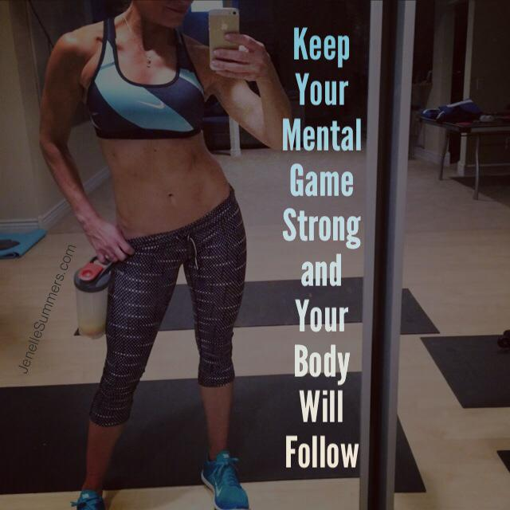

Day 14:
It's [DAY OF THE WEEK]!! How did it go?? If you fell off track - forgive yourself and get back today!
TIP OF THE DAY: Today we'll talk a little bit about "spot training" -- I'm sure you already know, you cannot target one area for fat loss, unfortunately. You gain fat in the areas you are genetically predisposed to gain fat. Two people with the same weight, height & body fat % can have entirely different bodies & trouble zones..it's genetics. BUT...You can still lose that fat in your trouble zones, it's just that the trouble zones will likely be the last area to shrink. It takes proper nutrition (including food types, portions, frequency & the necessary nutrients), cardio, sleep, water, stress relief, and STRENGTH TRAINING your entire body. #‎hello‬‬‬‬‬‬‬‬ #‎piyo‬‬‬‬‬‬‬‬
But, that said, gaining muscle in those areas DOES help the appearance of those areas. Muscle DOES increase your fat burning metabolism (the more muscle, the higher the metabolism), & muscle does give you your body its BEST shape.. among COUNTLESS other benefits
Check in below with your workout and nutrition for the day!!

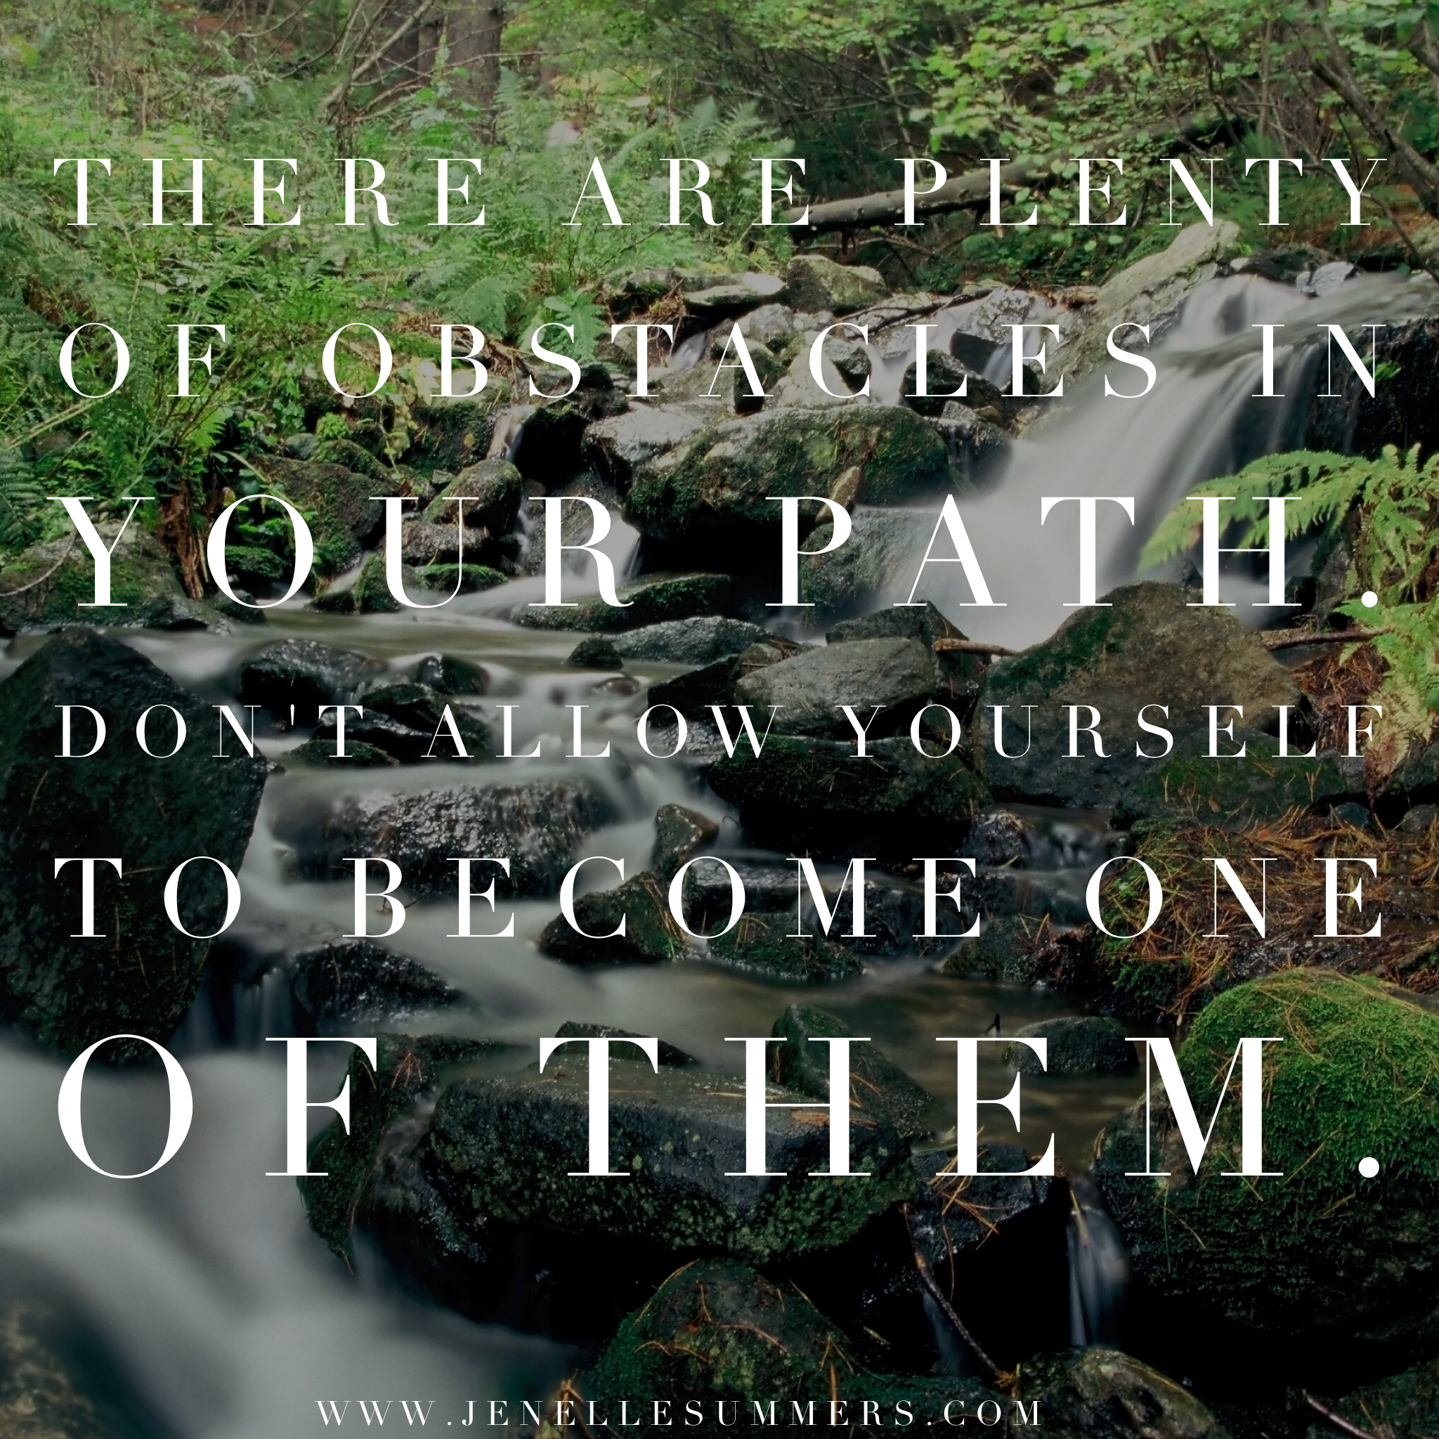

Day 15:
Happy [DAY OF THE WEEK] friends!!
How did you end up with your workout & nutrition today?

TIP OF THE DAY: Rules to Eat By (ive typed it out in case you want to copy/paste!)
- 20-30g protein at every meal
- Don’t buy bags/boxes of snack foods that will tempt you. Even if healthy! And if I must, I pre-portion them
- Double digit protein, single digit sugar
- Avoid/limit carbs before bed
- Don’t drink pop/soda
- If its hard to stick to 1 serving, I stop buying it
- Don’t eat fast food
- Don’t leave home without healthy snacks
- Drink water & a snack before going out to eat or a get-together
- Ballpark daily intake so I know I’m getting roughly enough & not too much, but not counting EVERY calorie or obsessing
- Don’t “diet down” or take on any new restrictive habits that I can’t realistically maintain.
- Follow lifting workout with muscle building-protein & avoid adding fat to it (slows delivery of protein to the muscles)
- Keep alcohol to special occasions only (slows metabolism, sluggish next day, and often causes off-track eating)

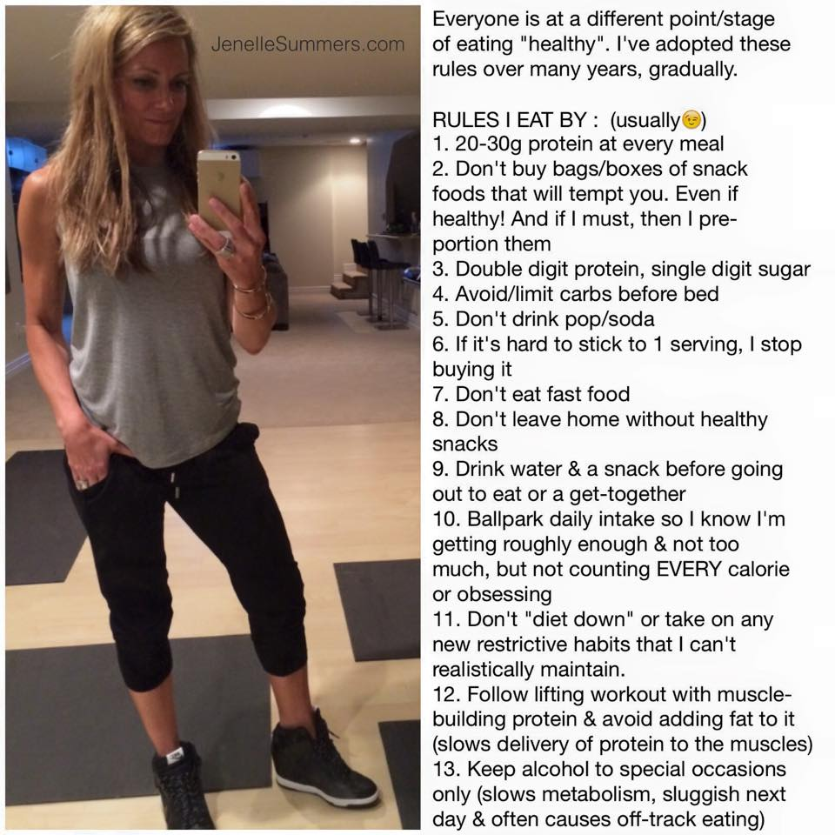

Day 16:
Hey Fit Fam! It's [DAY OF THE WEEK] night!
How was your workout today and your nutrition???
TIP OF THE DAY: It's a myth that you can target your fat loss to ONE area of your body. I get asked all the time.. "I just want to lose that pooch/lower belly area".. or "I just want my thighs smaller".. etc. Truth is, you cannot target your fat loss to happen in just one area. You CAN add muscle to those areas and make them appear MUCH better (yay!). Muscle LIFTS and shapes your body.. plus having more muscle means having a faster metabolism ..and who doesn't want a faster metabolism???
Your "trouble zones" are determined by your genetics. But the leaner and stronger you get, the less noticeable your "trouble zones" are, if they are noticeable AT ALL… because as you lose fat the proper way (focusing on nutrition, water intake, strength training for your entire body, etc), you WILL lose fat in your trouble zones too. Look at anyone who you THINK has the perfect body and they will surely tell you they have "trouble zones" but they seem nonexistent to us.. because they are so lean, we can't see them! But she/he knows where they are because they see them as soon as they start to gain weight. Spending too much time on ab work just because that's where you have weight to lose, is NOT a good use of your time. So even if you're legs are thin and your fat tends to be gained in your abdominal area, that does NOT mean you should focus on doing ab work and skip the squats (or vice versa). Having more developed leg muscles will HELP your body lose fat and yes, including the abdominal area! Strength train your whole body, have patience & trust the process Be GRATEFUL for what you DO have and the opportunity to improve every day!! We've got this!

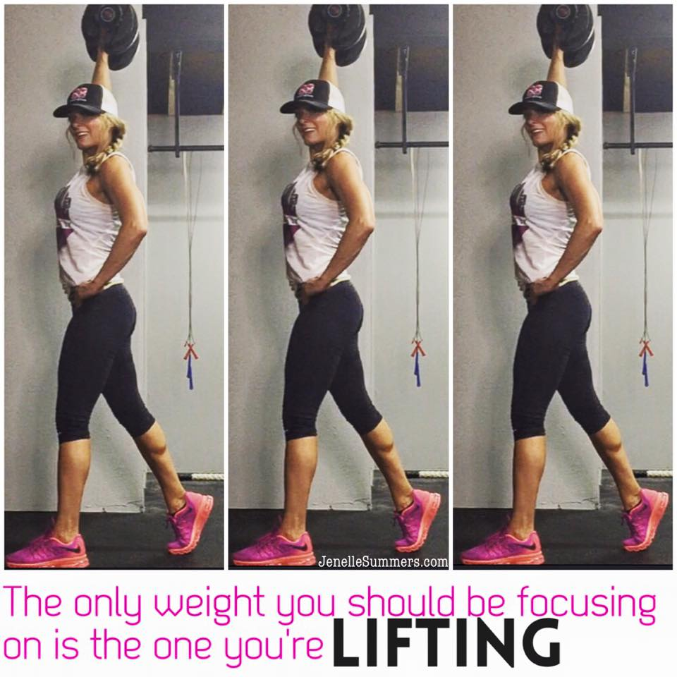

Day 17:
It's [DAY OF THE WEEK] night my friends!!
How'd you do today?? Did you fit in your workout? What was your nutrition like today?
TIP (COMMENT BELOW): As we come to a close on this group, keep in mind it's NOT too late to make some new changes starting TONIGHT. Please share with us below that "issue" you KNOW is holding you back; whether it be with nutrition or with working out.. what in the past has tripped you up? Maybe by sharing it here, amongst us friends who will NOT judge, one of us can offer tips that can help! Different things work for different people!
Even if you feel you fell off track this weekend or this past week, or for the whole challenge… the key to success in fitness, as you know, is NOT that you are on track 24/7, it's that when you fall off track, you get back on!
Someone asked me in a message what keeps me motivated -
First of all, people like YOU all keep me motivated! Challengers like you keep me accountable- I want to set an example I want to show others how fitness can benefit you in all areas of your life!
Secondly, if I DON'T workout and eat right, I know I won't feel as good about myself, I feel lethargic, i don't think as clearly, I am not as confident, I have more negative thoughts, I don't eat as well, I am more moody, PMS comes on stronger (true!), I feel my muscles are deteriorating and I’m getting older, etc. I workout & eat right because it brings me the opposite of all those things listed! I feel AMAZING after a workout and I love knowing I can eat healthy, without restricting, and just appreciate the journey and trust the process! Take baby steps towards improving your diet and improving your fitness every day.. let the results fall where they fall; everyone's body will react differently and in a diff timeframe to change.
I say this because we have members in this group who are not posting and I just want to say it's OK if you've not been participating but it's not too late to turn things around; but start NOW

Day 18:
HEY GUYS!! It's [DAY OF THE WEEK]!!! Did you do ok?? What was your workout today and how was your nutrition??
TIP OF THE DAY: I cannot stress how important it is to have people with you on this journey! It doesn't have to be your spouse/significant other (and believe me, forcing someone into fitness doesn't work). Find people who want more for themselves in life & want you to be at your best! Your coach has inspired YOU to be here in this group - who can YOU inspire to get into fitness? If you post about your results from this group (and I hope you do), tag your coach and your family members on the post - those who you know will congratulate you. Others will see that and you'll probably hear you're inspiring them.. it's a great way to find out who in your life is on this journey too, or WANTS to be on this journey too.
You can have little friendly competitions and sign up for races together (which forces you to TRAIN for them) … being on this journey alone is a CHOICE, but I hope you choose to step out and bring others along

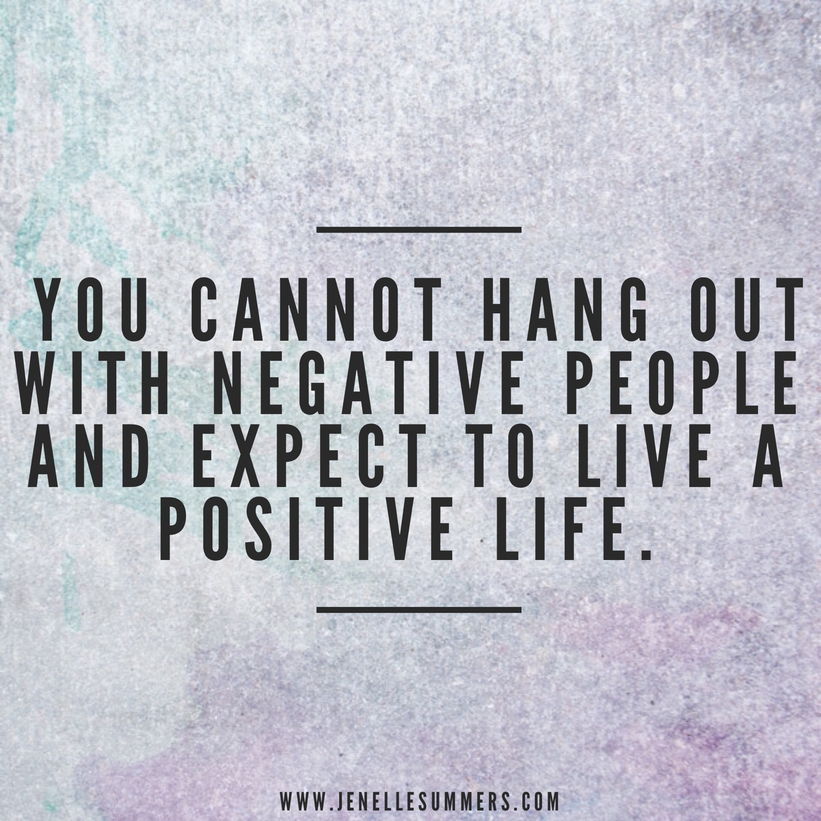

Day 19:
Hey guys! Its [DAY OF THE WEEK]! Once your kitchen is closed, please rate your fitness & nutrition for the day!
Need more tips & motivation?? Here are some people to follow for more lean & healthy eating:
www.katch.me/livingleanwitherin and Bret Johnson at www.katch.met/bretjohnson11 the Hangry Chef!
And for fitness & healthy eating, my coach at www.katch.me/jenellesummers
I hope these are helpful for you!! Who do you follow for motivation?

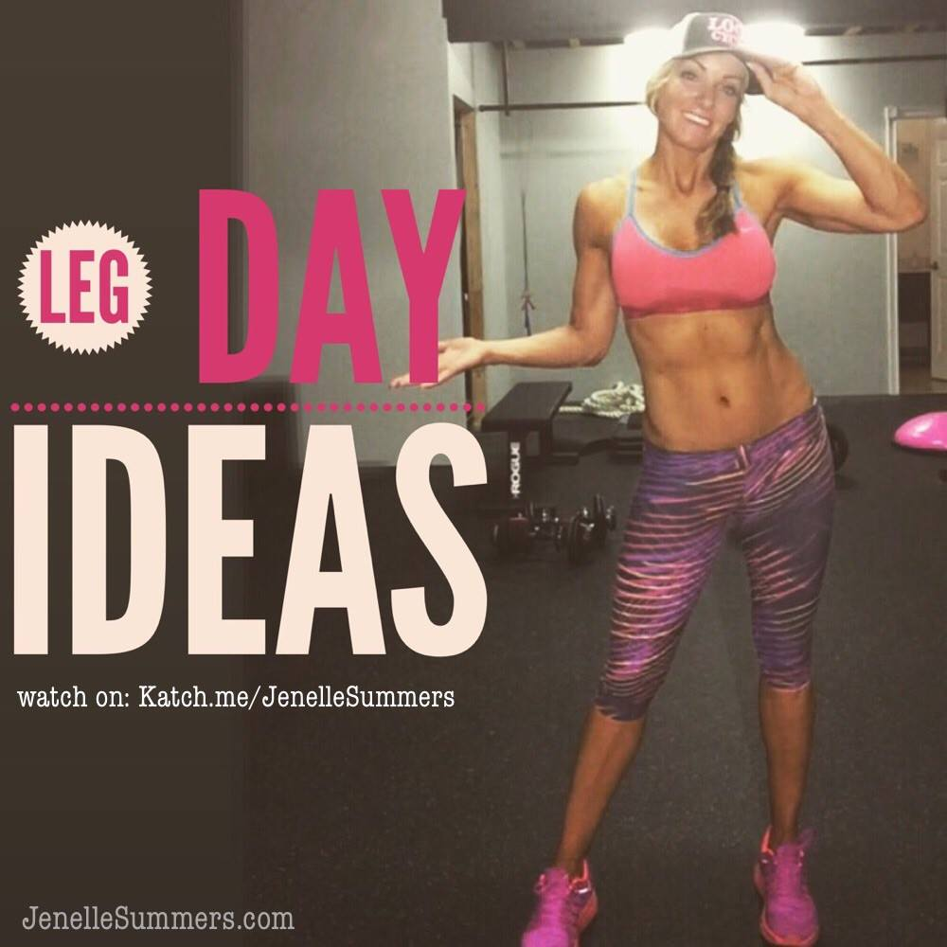
Day 20:
Happy [DAY OF THE WEEK]!!
When you check in for tonight, let us know how your workout and nutrition went :)

Ok so tell me - how do you feel now that you're working out regularly? Were you already doing it before? or is this completely new to you? Either way, i'm guessing you're feeling SO much better - more energy, less guilt, better body image, confidence, etc.
Working out isn't just about weight loss - its preventing all of the other crappy feelings you don't want to go back to!!!

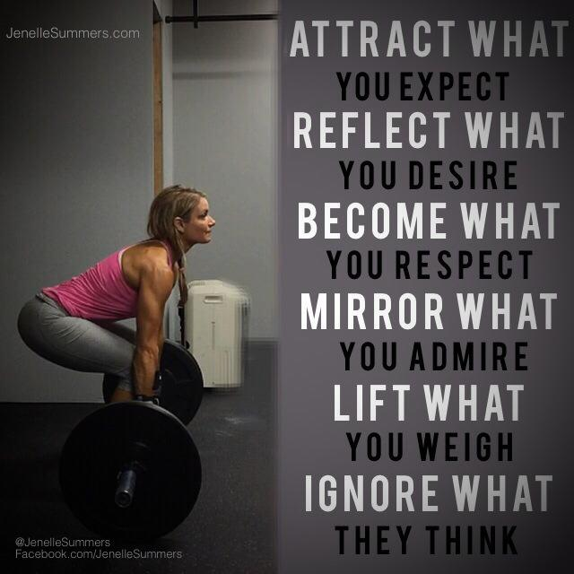
Day 21:
YOU DID IT!!!! Its [day of the week] and today was the last day!!! Please report below on today's progress!!
Please finish this day strong because tomorrow morning, first thing, you'll be taking measurements, weight and your "after" pics… you do not HAVE to share them with us but you are more than welcome to!
I truly enjoyed running this group and hope you learned some new things, gained some new motivation and started some new habits! Please share your goals moving forward as well:
1) Is this the end of your fitness journey and you're going to go on your own for now?
2) Do you want to be in another challenge group to continue the accountability?
OR
3) Do you have interest in becoming a coach to earn extra income or enjoy the discounts??
THANK YOU SO MUCH for all your participation and support of each other! What an amazing group we had here!

